Data Exploration and Insight:

Basic Summary about Data:

Total Content on Netflix : 8807 (Movies + TV Shows)
Available Columns : 12

Missing Data :
director 29.908028 %
cast 9.367549 %
country 9.435676 %

# in analysis above missing values are replace with "Unknown" category.

Number of Unique Values per Columns:
show_id 8807
type 2
title 8807
director 4529
cast 7693
country 749
date_added 1767
release_year 74
rating 17
duration 220
listed_in 514
description 8775

Type of Content On Netflix :

Movie 69.615079 %
TV Show 30.384921 %
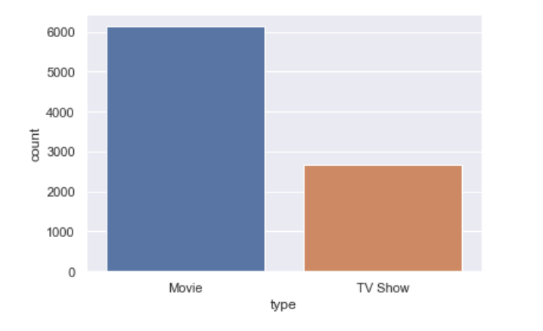

# Content added per year :

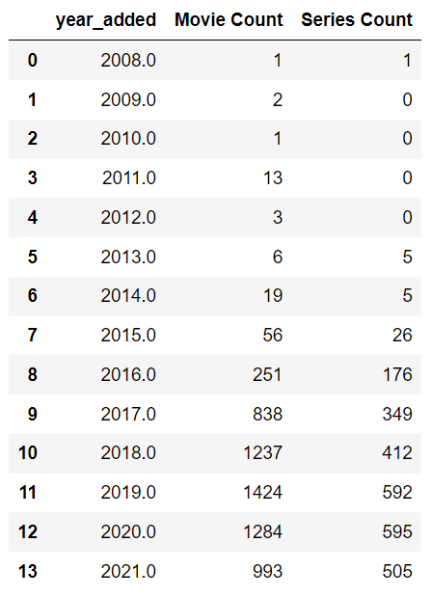

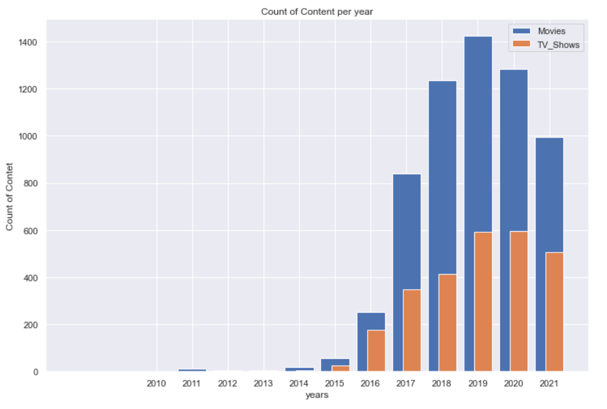
# here is the comparison of Number of Content added between years from 2010 to 2021 , by Movies and TV Shows!
# number of content has been increased from 2014 to 2019 .
# after 2019, number of content has been decreased.

# Number of Content released per Year in Last 30 Years

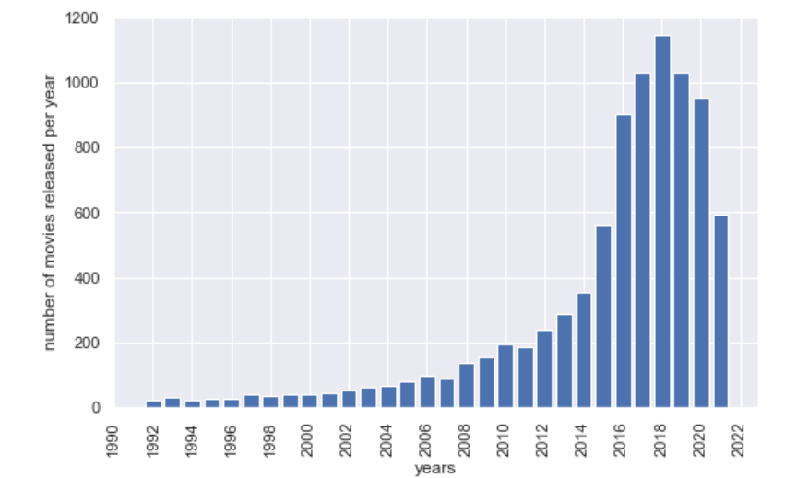
# possibly because of pandemic , count of releasing movies has been decreased .
Recommendation :
It would be appropriate decision if we add content based on past data as per best actors and directors , or produce more movies specifically for Netflix .

Number of Content Per Rating :

TV-MA 36.430762 % Adults
TV-14 24.537090 % Teens
TV-PG 9.803476 % Older Kids
R 9.076451 % Adult
PG-13 5.566284 % Teens
TV-Y7 3.794161 % Older Kids
TV-Y 3.487447 % Kids
PG 3.260252 % Older Kids
TV-G 2.499148 % Kids
NR 0.908781 % Adults
G 0.465750 % Kids

there are even more categories of rating , but 99.82% of data falls in above category.

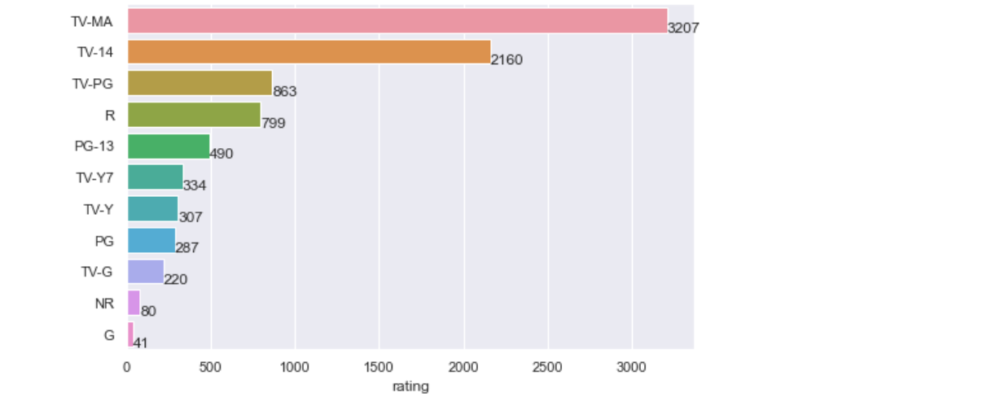

Above categories of Rating are for belove category people:

Adults 46.484153 %
Teens 30.103374 %
Older Kids 16.926048 %
Kids 6.452346 %
# Majority Content is for Adults and Teens Category
# Around 23% content is for kids and older kids.

Number of Content per Genre :

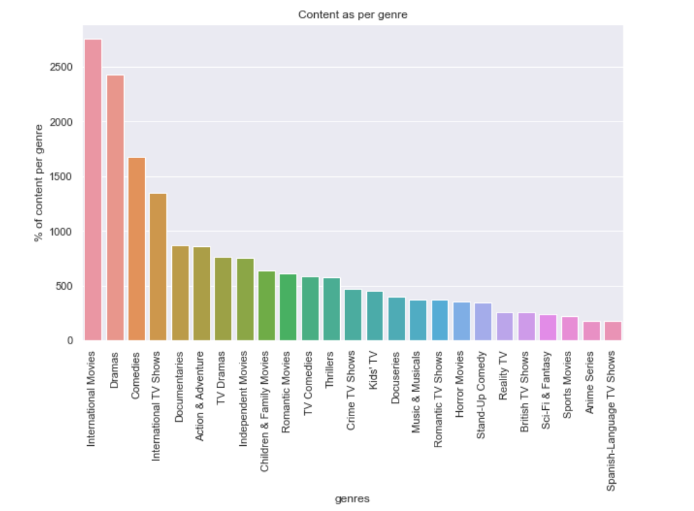

Top 23 Genres Globally watched on Netflix : (91% of total content are from below category of genres)
International Movies 14.242095 %
Dramas 12.560161 %
Comedies 8.663251 %
International TV Shows 6.991668 %
Documentaries 4.497231 %
Action & Adventure 4.445479 %
TV Dramas 3.948662 %
Independent Movies 3.912436 %
Children & Family Movies 3.317290 %
Romantic Movies 3.187911 %
TV Comedies 3.006779 %
Thrillers 2.986079 %
Crime TV Shows 2.432335 %
Kids' TV 2.334006 %
Docuseries 2.044196 %
Music & Musicals 1.940692 %
Romantic TV Shows 1.914817 %
Horror Movies 1.847539 %
Stand-Up Comedy 1.775087 %
Reality TV 1.319671 %
British TV Shows 1.309320 %
Sci-Fi & Fantasy 1.257569 %
Sports Movies 1.133364 %

# Currently Number of Content per Country on Netflix :

United States 3689
India 1046
Unknown 831
United Kingdom 804
Canada 445
France 393
Japan 318
Spain 232
South Korea 231
Germany 226
Mexico 169
China 162
Australia 160
Egypt 117
Turkey 113
Hong Kong 105
Nigeria 103
Italy 100
Brazil 97
Argentina 91

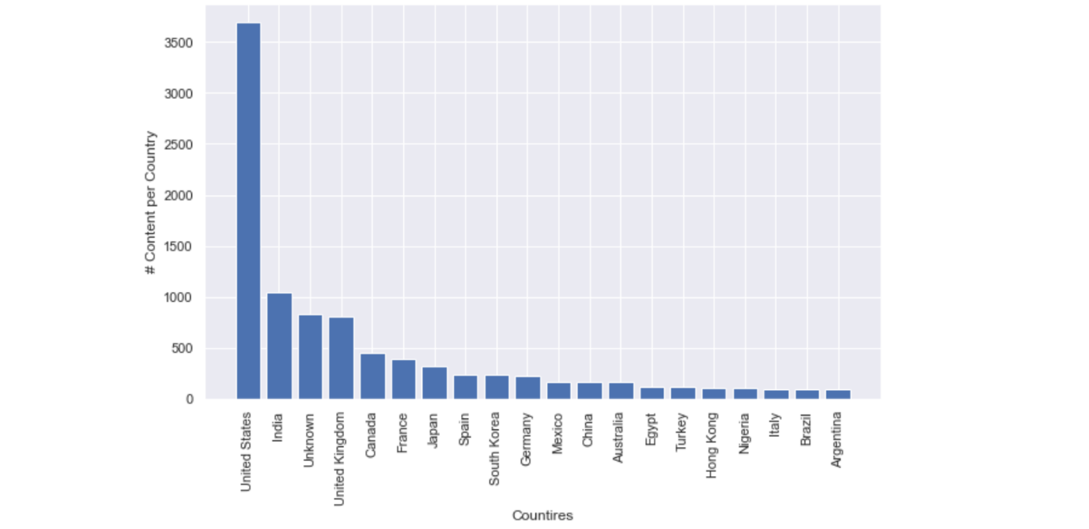

# 85% of the total Content is from :
United States 3689
India 1046
Unknown 831
United Kingdom 804
Canada 445
France 393
Japan 318
these countries .

if we see some counties :
like ,
Russia
China
Germany
South Korea
Mexico
Singapore
Poland
United Arab Emirates
New Zealand

there are some countries who have very good international presence , and some of them are having more population , means that there can be the potential customers from above country list!

Here are some recommended Actors and Directors who are having their content in maximum counties.

directors who have worked Internationally:
# directors # countries count
Matthew Salleh 12
Joshua Oppenheimer 10
Farhad Safinia 8
Martin Campbell 8
James Watkins 7
Aaron Woodley 7
Renny Harlin 7
Nora Twomey 7
Brian De Palma 7

Actors who have worked Internationally:

# actors # countries count

Alfred Molina 14
Paul Giamatti 14
Mads Mikkelsen 13
Ben Whishaw 13
James Franco 13
Eddie Marsan 13
Vincent Tong 13
Sylvester Stallone 13
John Cleese 13

Top 20 most versatile Actors
who have worked in various types/genres of Movies:

Number of genres per actor # number of movies they have done
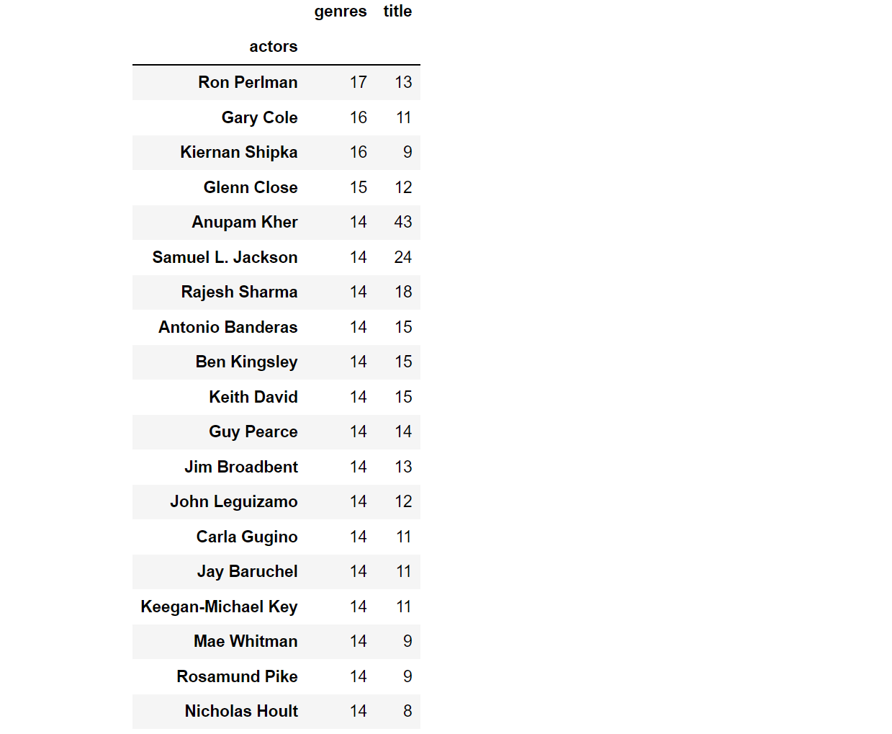

Top 20 most versatile Directors
who have worked in various types/genres of Movies:

#number of genres director has worked in # number of movies they have done
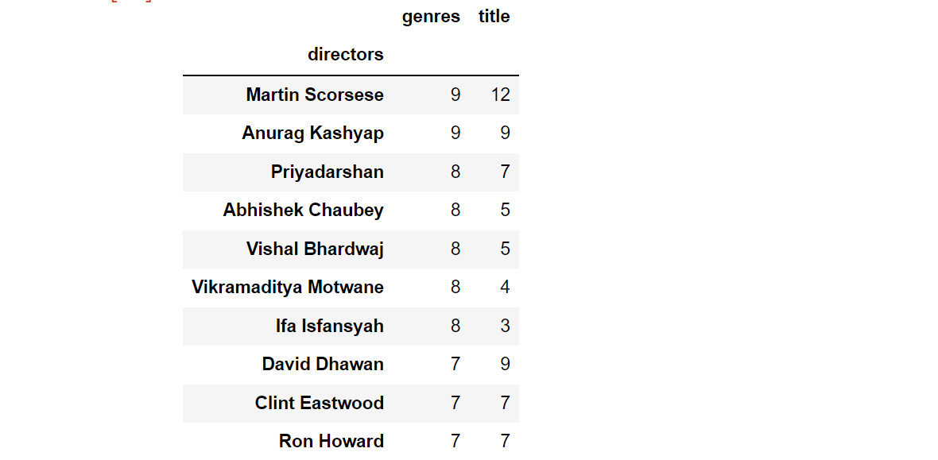

Change in duration of movies and series over the years :

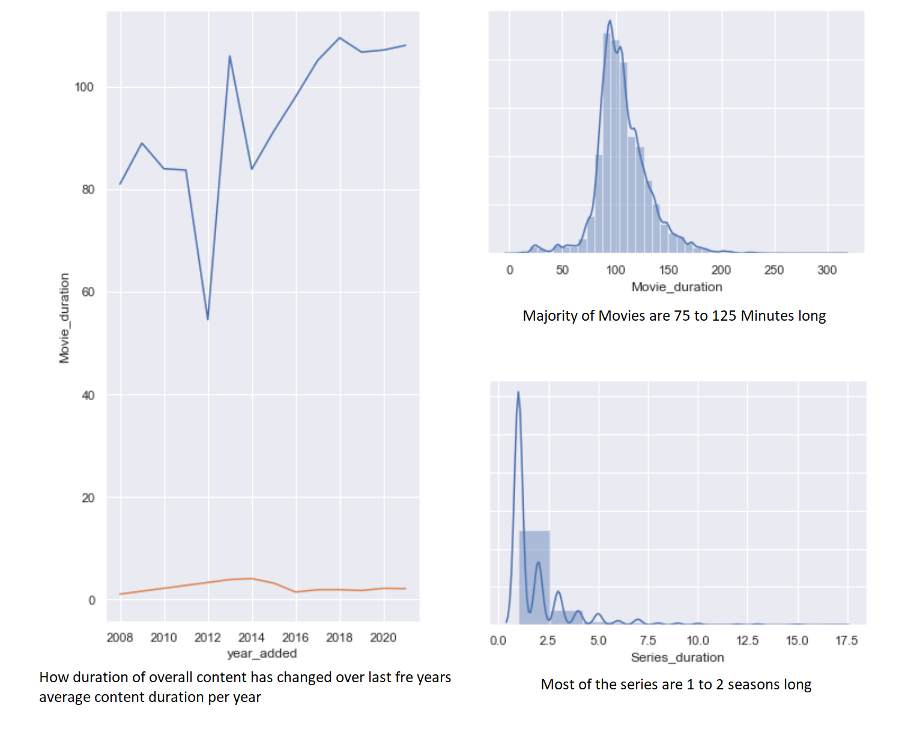

looks like majority of the Movie content is around 75 to 125 min long ! and Series/TV Shows are 1 to 2 seasons long .

adding longer content may or may not be beneficial

below is the data , for Movies and TV shows with highest duration :

# Recommendation :
below information can be helpful in increasing the watch time on Netflix by producing/adding their Movies/series.
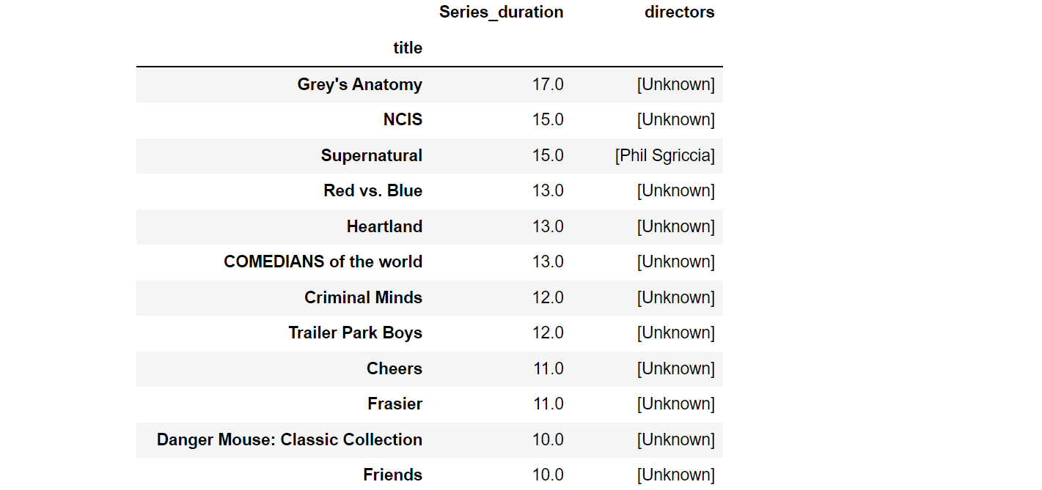
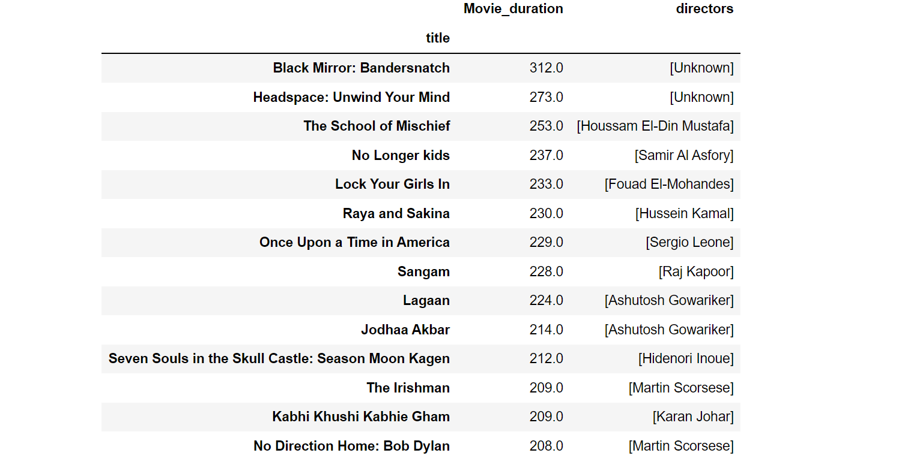

TV shows And Movie data

# types of content added on Netflix every year.

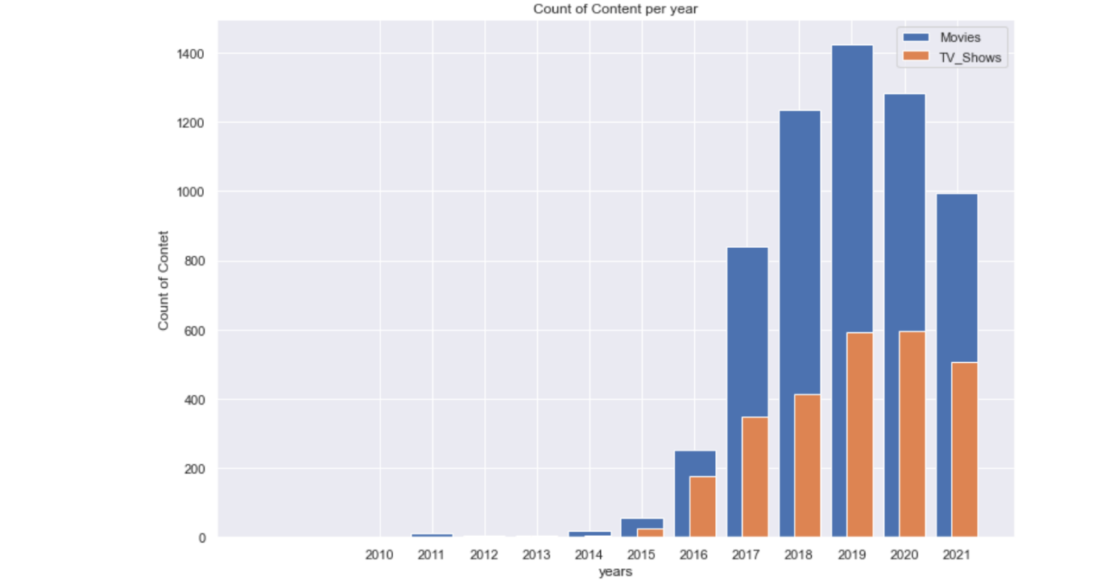
# Netflix has equal focus on adding movies and tv shows from 2015 .

Tv Shows and Movie counts for top Countries :
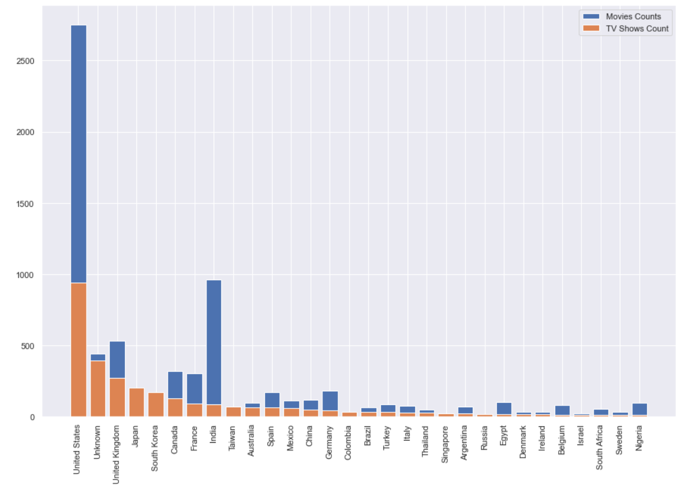
# from above chart:

we can conclude that some countries :
Japan , South Korea , Taiwan , Cambodia , Singapore , Russia
have more tv shows content compare to movies !
Recommendation :
Probably people from these counties are more interested in TV Shows than in Movies .
we can take this information into account and recommend to focus on producing or releasing new content for particular movie.
India and Unite States has more content of Movies and for rest of the countries it is equally distributed.

Best time to release movie/TV Shows :

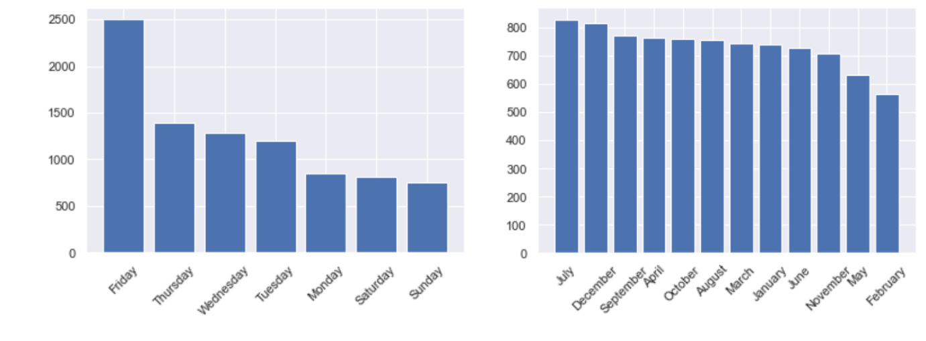

best time to launch/release the new content is : July , September and December months
on Friday !

# Recommended Actors/Directors as per Type of Content :

Actors/ # number of
Directors Contents

# Top 10 actors in TV Shows :
Takahiro Sakurai 25
Yuki Kaji 19
Junichi Suwabe 17
Daisuke Ono 17
Ai Kayano 17
Yuichi Nakamura 16
Jun Fukuyama 15
Yoshimasa Hosoya 15
David Attenborough 14
Vincent Tong 13

# Top 3 directors in TV Shows:
Ken Burns 3
Alastair Fothergill 3
Stan Lathan 2

# Top 10 Actors in Movies:
Anupam Kher 42
Shah Rukh Khan 35
Naseeruddin Shah 32
Om Puri 30
Akshay Kumar 30
Paresh Rawal 28
Julie Tejwani 28
Amitabh Bachchan 28
Rupa Bhimani 27
Boman Irani 27

# Top 10 directors in Movies:
Rajiv Chilaka 22
Jan Suter 21
Raúl Campos 19
Suhas Kadav 16
Marcus Raboy 15
Jay Karas 15
Cathy Garcia-Molina 13
Martin Scorsese 12
Jay Chapman 12
Youssef Chahine 12

# How We can help Netflix in deciding which type of content to produce and how they can grow the business in different countries :

# here is the list of Most Popular genres per for Countries having highest users :

<< United States >>
['Comedies', 'Dramas', 'Children & Family Movies']

<< India >>
['International Movies', 'Dramas', 'Comedies']

<< United Kingdom >>
['Dramas', 'British TV Shows', 'International Movies']

<< Canada >>
['Comedies', 'Children & Family Movies', 'Dramas']

<< France >>
['International Movies', 'Dramas', 'Independent Movies']

<< Japan >>
['International TV Shows', 'Anime Series', 'Action & Adventure']

<< Spain >>
['International Movies', 'Dramas', 'International TV Shows']

<< South Korea >>
['International TV Shows', 'Korean TV Shows', 'Romantic TV Shows']

<< Germany >>
['Dramas', 'International Movies', 'Comedies']

<< Mexico >>
['Spanish-Language TV Shows', 'International Movies',
'International TV Shows']

Top Genres / Actors / Directors from USA, that we can recommend based on their Content Counts :

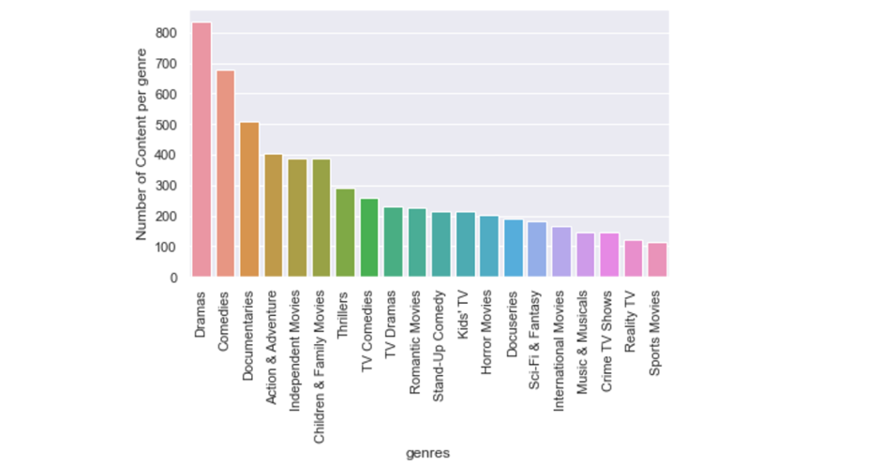
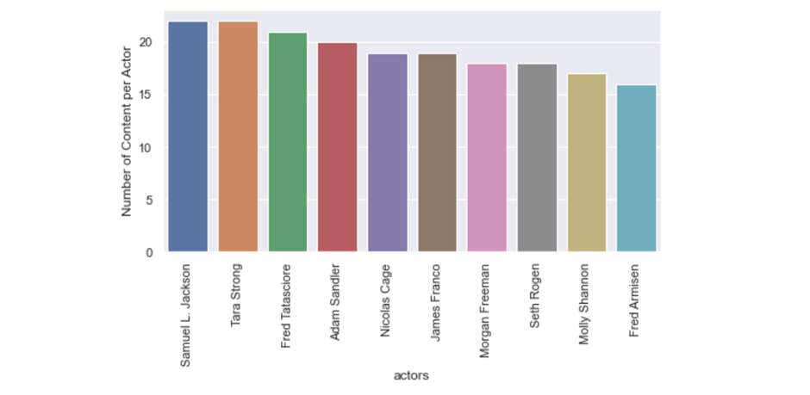
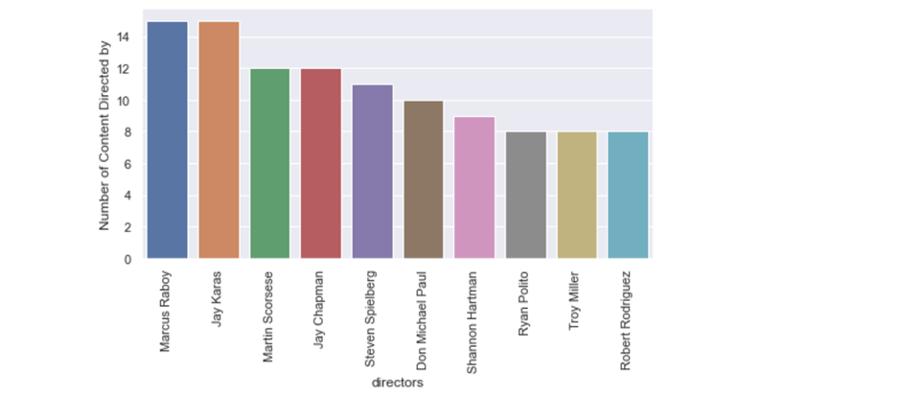

Top Genres / Actors / Directors from India, that we can recommend based on their Content Counts :

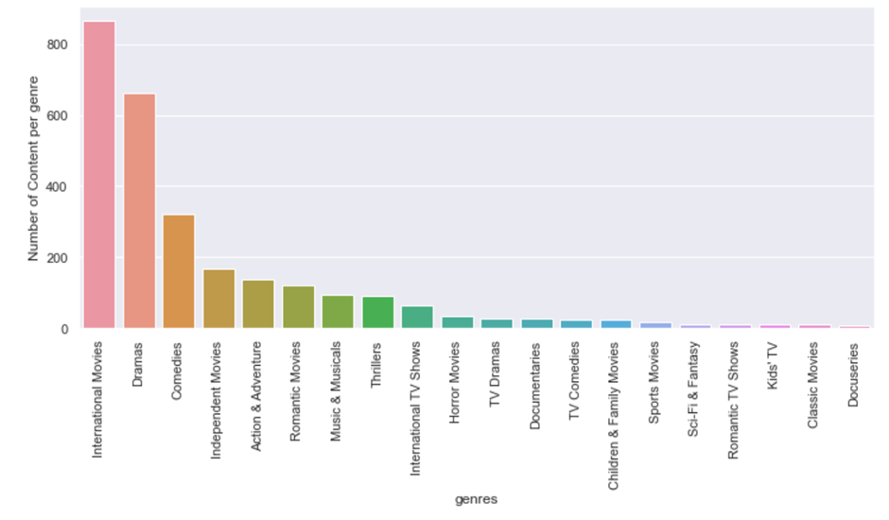
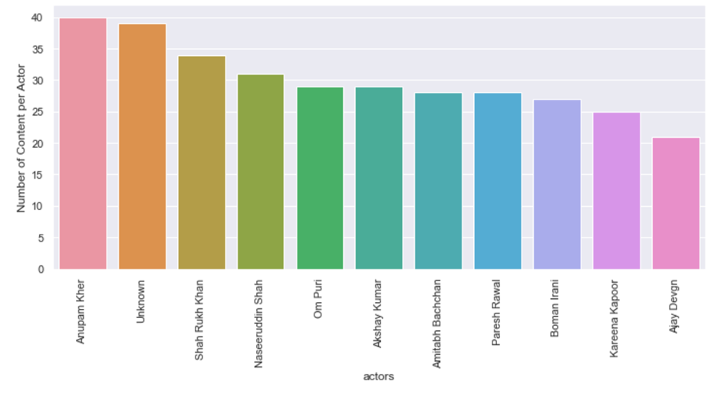
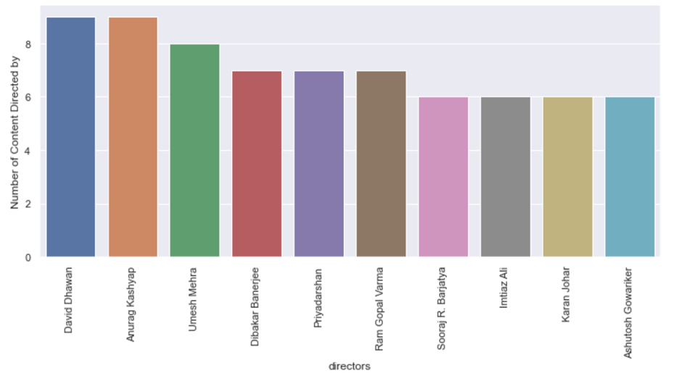

Top Genres / Actors / Directors from UK, that we can recommend based on their Content Counts :

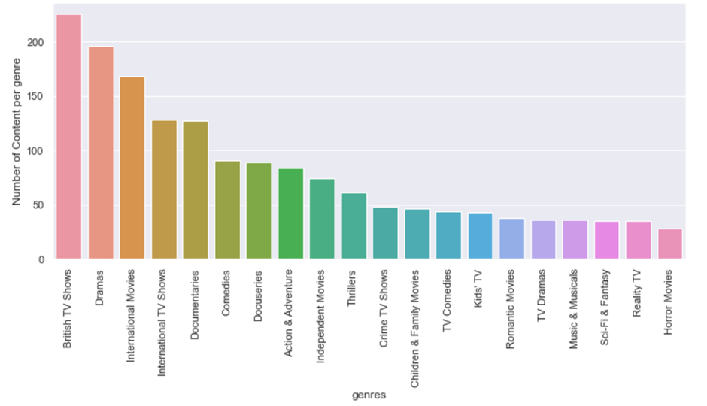
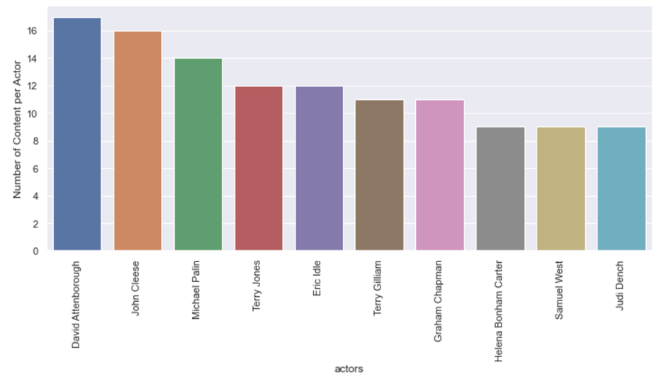
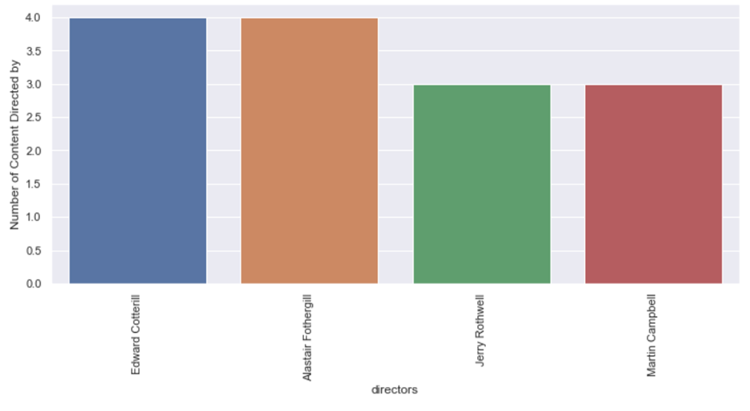

Apart from Highest Subscribers Countries :

People from other countries can be potentials subscribers :
Those countries are :

Russia
China
Germany
South Korea
Mexico
Singapore
Poland
United Arab Emirates
New Zealand

Recommend to release or produce the content from below list :
Lists Contains best Actors , directors and most preferred genre by the countries above listed.
which can help get new subscribers and grow in business in those particular countries.

Some countries out of these lists , have a good international cities like, Dubai , Auckland, Beijing , Frankfurt etc . and some are very high population , there can be great potential subscribers from those cities :

